Task 1: [5 marks]
- Use the following code snippet to download unigrams and bigrams data, and load them into their corresponding dataframes, unigrams_df and bigrams_df
from IPython.core.display import display, HTML
import pandas as pd

!wget https://norvig.com/ngrams/count_1w.txt #unigram data
!wget https://norvig.com/ngrams/count_2w.txt #bigram data

filePath1 = "/content/count_1w.txt"
Expected Output:

sentence= ['i', 'love', 'you']

i love

bigram count for "i love" = ?
unigram count for "i" = ?
bigramProbability for "i love" = ?

love you

bigram count for "love you" = ?
unigram count for "love" = ?
bigramProbability for "love you" = ?

sentenceProbability for "i love you" = ?

sentence= ['i', 'hate', 'you']

i hate

bigram count for "i hate" = ?
unigram count for "i" = ?
bigramProbability for "i hate" = ?

hate you

bigram count for "hate you" = ?
unigram count for "hate" = ?
bigramProbability for "hate you" = ?

sentenceProbability for "i hate you" = ?

probability("i love you")>probability("i hate you") is: [True,False]?

sentence= ['OOV1', 'OOV2']

OOV1 OOV2

bigram count for "OOV1 OOV2" = ?
unigram count for "OOV1" = ?
bigramProbability for "OOV1 OOV2" = ?

sentenceProbability for "OOV1 OOV2" = ?
filePath2 = "/content/count_2w.txt"

unigrams_df = pd.read_csv(filePath1,sep='\t',header=None, names=['unigram','count'])
bigrams_df = pd.read_csv(filePath2,sep='\t',header=None, names=['bigram','count'])

print(unigrams_df.shape, bigrams_df.shape)
print(f'Number of unigrams: {unigrams_df.shape[0]} Number of Bigrams: {bigrams_df.shape[0]}') # df.size VS df.shape

display(unigrams_df.head(100),bigrams_df.head(100))

- Complete the function below to compute the probability of a given sentence using the unigram and bigram counts from (a). Do not apply add-one smoothing [3 marks]
def probability(sentence):
YOUR CODE HERE

#TESTING
probA = probability("i love you")
brobB = probability('i hate you')
print(f'probability("i love you")>probability("i hate you") is: {probA>brobB}\n')
probability("OOV1 OOV2") # Test for OOV (Out Of Vocabulary) N-grams

- Copy the function from (b) into a new code cell, and modify it such that it applies add-one smoothing. Your new function should also address the problem of underflow when computing a sentence Probability [2 marks]

Task 2: [5 marks]
Using the bigram counts (bigrams_df), write a function that implements the Shannon visualization method:
def ShannonVisualization(seed=”<S>”):
YOUR CODE HERE
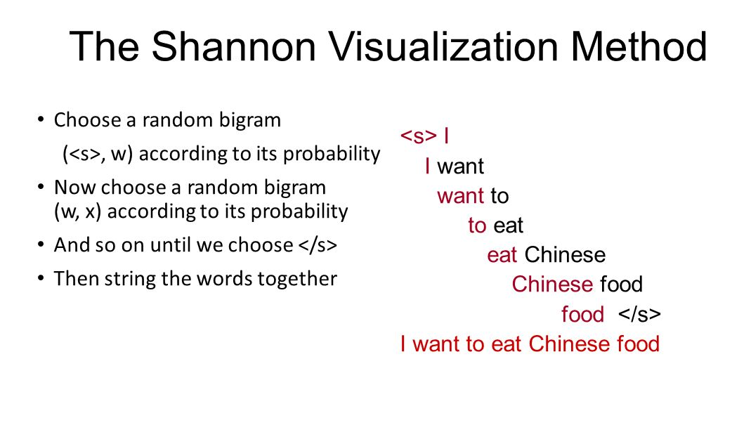
Chapter 3, section 3.4 gives a detailed description of the Shannon Visualisation method; a screenshot of this section is provided below. If you can follow the logic applied to unigrams, then you should be able to apply the same logic to bigrams.
Note: given the large size of the bigrams data, the Shannon Visualisation sampling can continue for a long time; therefore, for initial testing, you could terminate the sampling early whenever a common word (e.g. “and”) is generated as the next new seed.
Extra Help:
- the seed word can be any word, but let's stick to the default seed word <S> which indicates the beginning of the sentence.
- First, you need to retrieve a list of all the bigrams starting with <S>, and then randomly select one of them according to its probability. Understanding this last part is key! You have a probability space between 0 and 1 and each of the candidate bigrams covers an interval in this space proportional to its frequency. For example, the candidate bigram “<S> and” has a total frequency of 261891475 which translates to a probability of 0.031513. If you consider this bigram to be your first candidate, then you can assign the probability interval 0.0 to 0.031513 to it. There are 8640 bigrams in the dataset which start with <S> and you need to compute the probability intervals for all of them.
- Then Generate a random number between 0 and 1 and check to see which interval it falls into, and that would be your chosen bigram.
- Pick the second word in the chosen bigram and that would be your new seed word.
- This process should be repeated until you either reach </S> (indicating the end of the sentence) or come across a seed which does not exist in your list of bigrams (i.e. there is no bigram starting with this seed word).

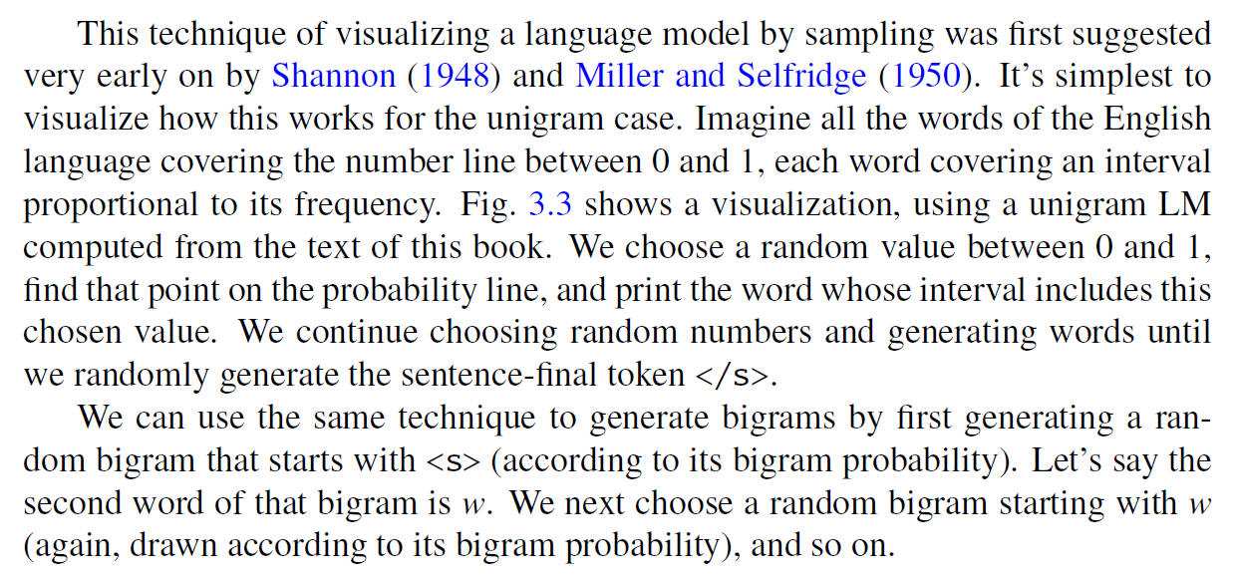
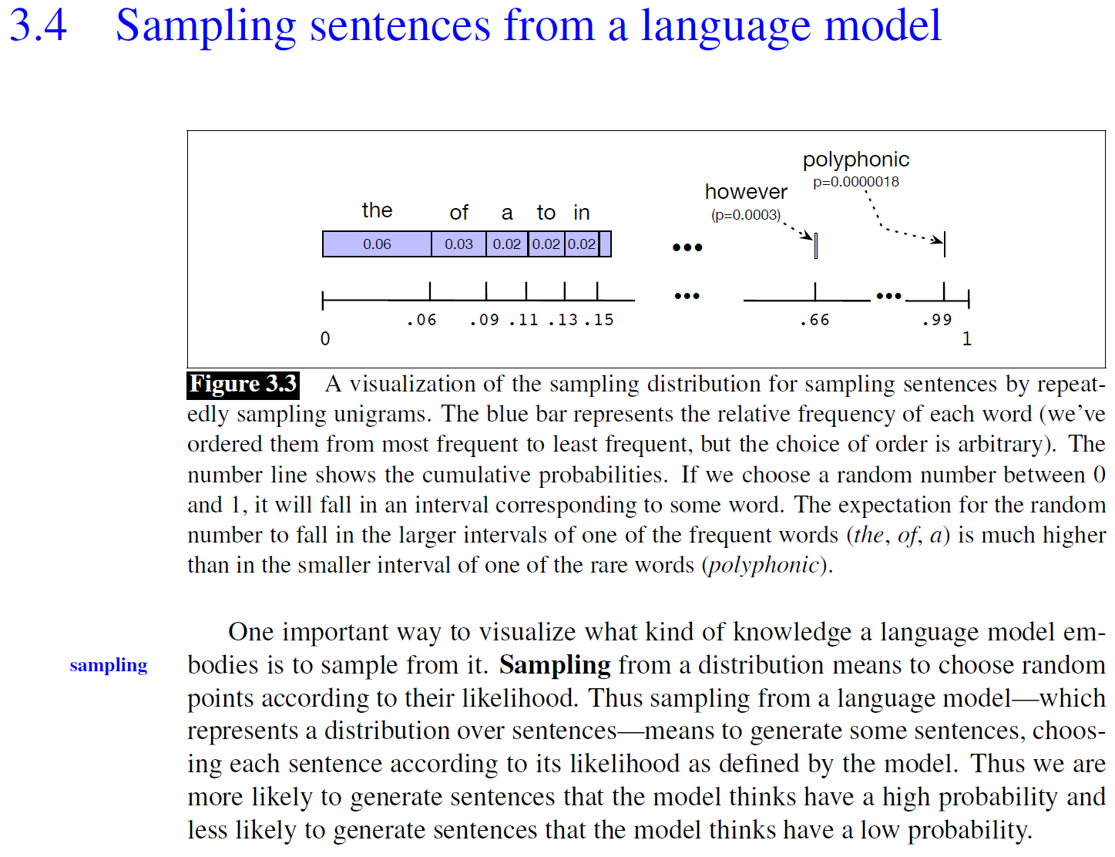

</END OF ETIVITY>

Teaching team_ :
- Level of difficulty (easy/fair/hard)_
- Task 4: use the Shakespeare corpus to create new unigram and bigram dataframes
- Task 5: deployment of a modern language model api/lib
- TASK2.B print V, use loc and iloc
- Train an LM
- Higher n-gram language models
- Nlp - 2.7 - Good-Turing Smoothing
- Task1.c convert back to prob by taking the exp_

